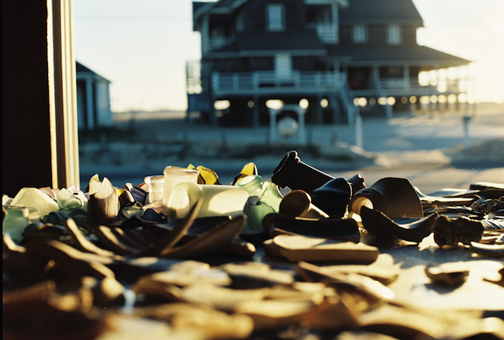

Glass shards at the Beachcomber Museum face the historic Buchanan Cottage, Old Nags Head

**Outer Banks Beachcomber Museum treasures trek to Santa Cruz Beach Glass Festival**

Nags Head, N.C. … A rare sea glass and beachcomber’s artifact collection will leave the East Coast for the Santa Cruz Sea Glass and Ocean Art Festival in California, Nov. 3 and 4.

The occasion will mark only the third time in history that pieces from the Outer Banks Beachcomber Museum’s Nellie Myrtle Pridgen collection have left Nags Head, North Carolina in the last 60 years.

Museum stewards Dorothy Hope and Chaz Winkler have culled select items from the exhibit’s permanent collection featured in an October 1987 *National Geographic* story written by Charles E. Cobb Jr.

This month, a priceless string lip shard, a Dutch gin bottle bottom, a deep teal Baltimore beer bottle and a stunning amber Vaseline jar bottom will leave Nags Head bound for Santa Cruz.

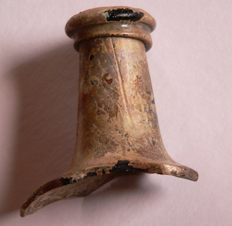

String lip bottle, circa mid-1700

Richard LaMotte, North American Sea Glass Association president and author of the bestselling *Pure Sea Glass*, has visited the Beachcomber Museum and has appraised the collection for its rare treasures.

LaMotte says, “When it comes to beachcombers of the 20th century, no one single collection comes close to the wealth of artifacts as those amassed by Nellie Myrtle Pridgen. Her trove of gifts from the shoreline and dunes of Nags Head serves as a 60-year time capsule of life on the Atlantic as items adrift from north and south found respite along North Carolina's Outer Banks. The shelves of a once thriving grocery store display thousands of stunning sea glass shards and dozens of antique bottles.”

“Like the reclusive collector herself, the diverse items from our past have remained mostly out of the public eye,” LaMotte says. “She passed away in 1992 and never desired attention for her collection. Chaz Winkler and Dorothy Hope now carefully watch the store and its treasure. Their reluctance to move anything out of the nest is easily understood. Members of the beachcombing community would likely agree this is the immaculate collection.”

Carole Lambert, author of *A Passion for Sea Glass*, devoted an entire chapter, “Soul of the Outer Banks,” to Nellie Myrtle Pridgen and the Beachcomber Museum’s collection.

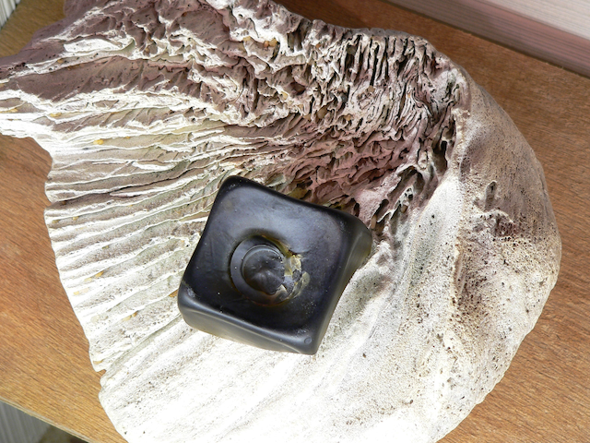

NMP Beachcomber Museum’s c. 1800 gin bottle bottom with whalebone fossil

In 2004, pieces from Nellie Myrtle Pridgen’s collection were exhibited by her daughter and son-in-law, Carmen and Billy Gray, who accompanied Hope and Winkler for the first Northeast Sea Glass Festival in Rockport, Mass., where they met Richard LaMotte.

Last month, Hope and Winkler attended the North American Sea Glass Festival in Virginia Beach, Va. For the Santa Cruz Sea Glass Festival they will exhibit prized pieces for show-and-tell and photographs of Nellie Myrtle Pridgen’s collection.

The Santa Cruz Sea Glass Festival at Coconut Grove on the Boardwalk is expected to attract thousands. Ten percent of all admission is donated to the new Monterey Bay National Marine Sanctuary Exploration Center in Santa Cruz, which opened this summer. For more information about the Santa Cruz Sea Glass Festival visit http://www.santacruzseaglass.com/festival.html

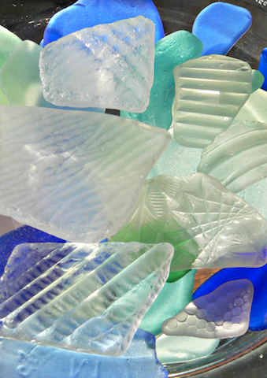

Sea glass shards from the Nellie Myrtle Pridgen Beachcomber Museum collection

For Winkler, a native of San Diego, the West Coast trip will retrace the legacy left by his ancestors. One, a grandmother Dorothea Winkler, was a well-known Impressionist painter in Los Gatos. Still another, his great, great aunt was Emma Cohen, who with her husband was the original owner of the 1882-1884 Cohen-Bray House in Oakland.

Winkler’s great, great, grandfather, Henry Perrin Coon, was the 11th mayor of San Francisco from 1863-1867. After leaving office, Coon amassed enough wealth to purchase two large ranches, one of which became part of the campus of Stanford University. He also hired a crew to survey a sandy area in the western part of the city that would become the site of Golden Gate Park.

For a detailed history of Nellie Myrtle Pridgen’s beachcombing days read: Lorraine Eaton’s “Beachcomber: The lady of the sand published Aug. 12, 2012 in *The Virginian Pilot/HamptonRoads.com* [http://hamptonroads.com/2012/08/beachcomber-lady-sand](http://hamptonroads.com/2012/08/beachcomber-lady-sand" \t "_blank), or visit the Outer Banks Beachcomber Museum website at http://www.oldnagshead.org/

Contact: Chaz Winkler (252) 564-5317, Outer Banks Beachcomber Museum, beachcombermusuem@gmail.com

